EV Market Segmentation

Ashwin Dayanand

Problem Statement

You are a team working under an Electric Vehicle Startup. The Startup is still deciding in which vehicle/customer space it will be develop its EVs. You have to analyse the Electric Vehicle market in India using Segmentation analysis and come up with a feasible strategy to enter the market, targeting the segments most likely to use Electric vehicles. (CUSTOMER/VEHICLE/B2B) SEGMENTS: Apart from Geographic, Demographic, Psychographic, Behavioral segments, teams can consider different CATEGORY of Segments for the Segmentation Tasks, based on AVAILABILITY OF DATA. Market Segmentation comes with wide scope of possibility and Segments created can change based on different datasets collected.

ML MODEL USED

The code uses the KPrototypes clustering algorithm (from kmodes library) for market segmentation.

KPrototypes is particularly useful because it can handle both numerical and categorical data simultaneously, which is important for this dataset that contains mixed data types like marital status (categorical) and salary (numerical).

The code tests different numbers of clusters (1-7) and plots the cost function to help determine the optimal number of clusters.

The Code also Uses Supporting Techniques

1)Standard Scaling

2) Silhouette Score

The code shows extensive use of visualization techniques through:

* Scatter plots
* Line graphs
* Violin plots
* Bar graphs
* Doughnut charts
* Multiple line plots for different metrics

Conclusion

* There's a relationship between marital status and car loan requirements (shown through countplots)
* The pie chart shows the overall distribution of car loan requirements
* Consumer features (Age, Dependents, Total Salary, EV Price) distributions are analyzed through line charts
* **Price Sensitivity**: The relationship between EV price and customer attributes, such as income and loan preferences, highlighted the segment of customers more likely to consider car loans for EV purchases.
* The project combines both EV market data and behavioral data to understand customer segments

Requirements

Improvements

Additional Data Collection: Incorporate data that enhances demographic and psychographic understanding, such as:

Age and Occupation: For identifying income-related trends.

Geographical Data: Location or zip codes to capture regional market variations.

EV Usage Patterns: Information on how often EVs are used or average daily kilometers.

Environmental Preferences: Preferences or awareness of sustainability to target eco-conscious segments.

Advanced Models: Additional ML algorithms, such as DBSCAN for density-based clustering or Gaussian Mixture Models (GMM) for identifying softer clustering boundaries, could reveal deeper patterns. Principal Component Analysis (PCA) could also help reduce data dimensionality, improving the interpretability of customer segments.

Estimated Market Size

The EV market size varies by region, but globally, the market for electric vehicles is experiencing rapid growth. As of 2023, the global EV market size is projected to exceed $250 billion and is expected to grow at a CAGR of over 20% through the next few years. Accurate regional or country-specific numbers would depend on market reports or detailed sales data.

Features which can be used to create the most optimal Market Segments for your Market Domain.

Total Salary: Strong indicator of purchasing power, especially in luxury or high-cost EV segments.

Age: Influences preferences for technology features, environmental impact, and financing options.

Car Loan Requirement: A direct indicator of price sensitivity and financing needs.

EV Price: Core factor that directly affects affordability and target segment type.

Shows the distribution of EV prices across the dataset

Shows relationship between EV range and price

Shows price distribution across different powertrains

Shows distribution of different plug types

Shows trends for four key metrics:

Top Speed

Range

Efficiency

Fast Charge capability

DATASET 2

Shows car loan requirements by marital status

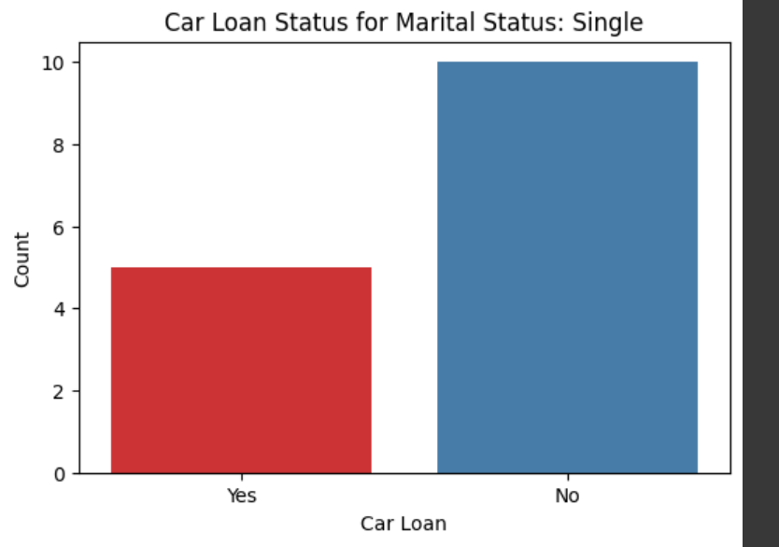

Shows car loan requirements by marital status

Four separate line charts showing frequency distributions for:

* Age
* Number of Dependents
* Total Salary
* A graph of a graph of a graph

  Description automatically generated with medium confidenceEV Price

Shows the cost function values for different numbers of clusters

<https://github.com/Ashwin1235/Market_Segementation_2/tree/main>